John Michael Go
Career Entry Level Java Programming
Date: Jan. 22, 2013

DAY 8

Program Name: Array7

Objective: Program that sorts an integer array.

Algorithm:

1.Program sorts integers in an array.

Flowchart:
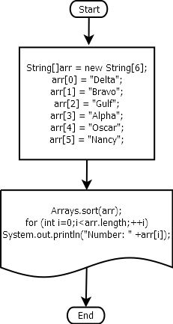

Pseudocode:

import java.util.Arrays;

public class Array7 {

public static void main(String[] args) {

String[]arr = new String[6];

arr[0] = "Delta";
arr[1] = "Bravo";
arr[2] = "Gulf";
arr[3] = "Alpha";
arr[4] = "Oscar";
arr[5] = "Nancy";

Arrays.sort(arr);
for (int i=0;i<arr.length;++i)
System.out.println("Number: " +arr[i]);

}
}

Screenshots:

